1. **Performance Matrix**
   1. Performance
   2. Accessibility
   3. Best Practices
   4. SEO (Search engine optimization)

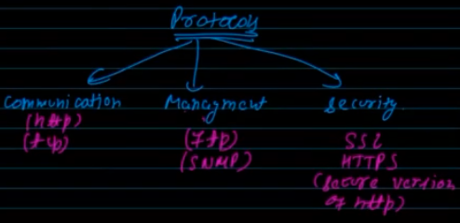

**Protocols**

1. 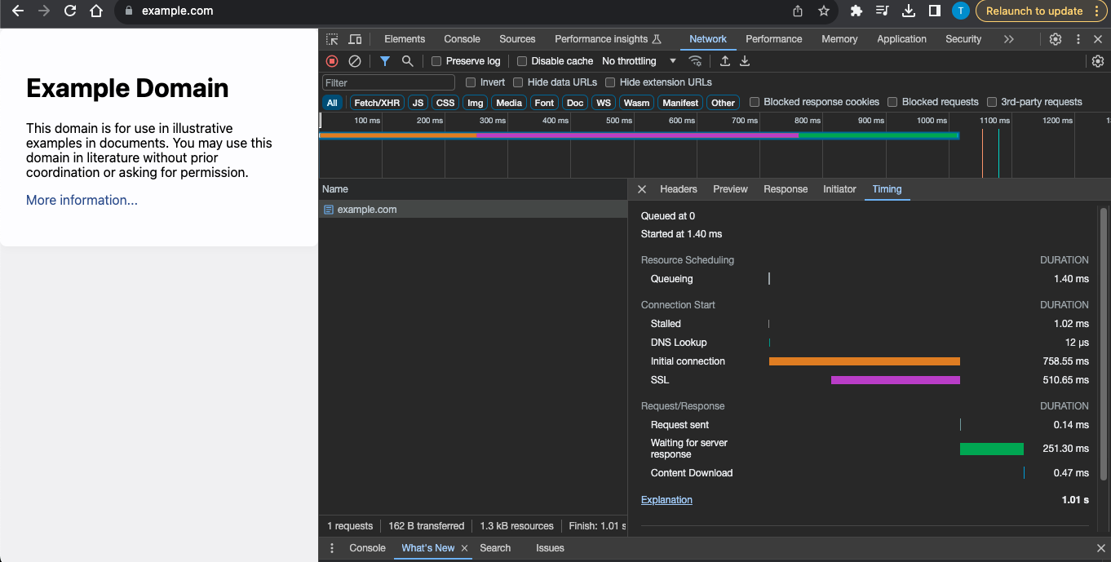

These are the step wise processes being executed when we try to process any page in browser.

The first step is the queueing phase, which is totally depend on the OS and browser.

A web application performance is dependent on machine OS and browser also.

1. **DNS lookup - check the DNS notes.**
2. 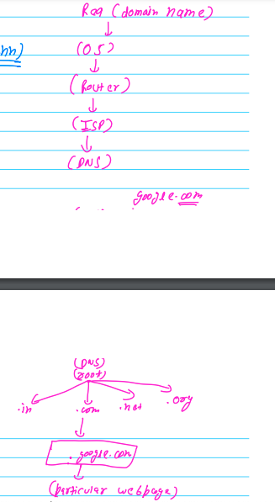

DNS lookup hierarchy when we try to hit any URL in the browser (ICANN manages the number with the domain name)

1. **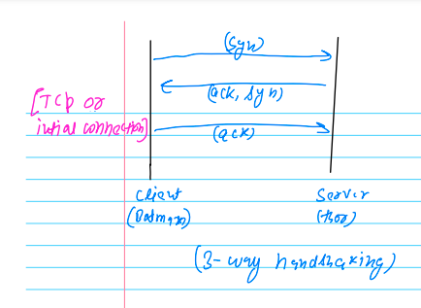  
   Initial connection: 3 way handshaking -**The three-way handshake is a fundamental process used in computer networking to establish a reliable connection between two devices  
   It is a key component of the Transmission Control Protocol (**TCP**), which is widely used for communication over the Internet.  
   **https://www.linkedin.com/pulse/understanding-tcp-3-way-handshake-computer-networking-haque/**
2. 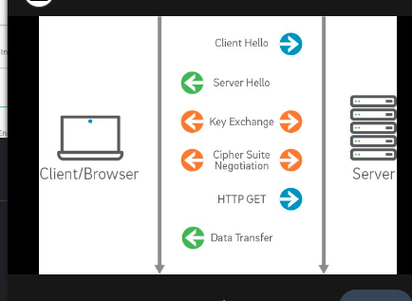

**SSL**

1. 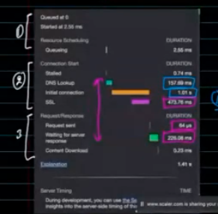Time taken in between Req and Response [from DNS look up to end of waiting for server response] which is called **latency**.
2. **Time to receive ur first byte(first html page)**
3. **14kb-**[**https://www.tunetheweb.com/blog/critical-resources-and-the-first-14kb/**](https://www.tunetheweb.com/blog/critical-resources-and-the-first-14kb/)
4. **Parsing (is a single threaded process)**

**Create a DOM structure**

* 1. **Rendering - static web page using the CSSOM and DOM tree those got created from parsing pahse –  
     then page becomes interactive (the events in the html page)**

1. **https://www.submarinecablemap.com/**